Yong Kai En (S10173513B)

Nathan Tan Hong Da (S10175720H)

Tan Jian Zhen (S10177664C)

**Description of Application**

Mezcla is an application that allows users to search for relevant cocktails based on the ingredients they have entered. The application also provides users with the nearest nightlife locations that are close to their GPS location. The application utilizes “TheCocktailDB” as its database. (<https://thecocktaildb.com/api.php>)

**Features**

|  |  |
| --- | --- |
| Feature Name | Functionality |
| Login | User will need to enter their login credentials to access the application |
| Registration | User is able to register for an account using their email address and password |
| Profile Setup | After the user has successfully registered his account, they will need to select a display picture and enter a display name |
| Logout | The user is able to log out of their account in the Settings page |
| Search by ingredients | User can enter one or more ingredients in the search bar and the application will display a list of drinks that contain the ingredient |
| Search by cocktail name | User can search for a particular cocktail drink by entering the name, and the application will display the search results based on the query |
| Nearest nightlife locations | User can view the nearest nightlife location and their own current location |

|  |  |
| --- | --- |
| Member | Contributions |
| Yong Kai En | Basic functionalities such as Login, Register, Edit Profile, View Profile, Maps etc  Validations |
| Tan Jian Zhen | Bringing in the API and scrape relevant data that our application requires  Search functions such as “Search By Ingredient” and “Search By Cocktail Name” |
| Nathan Tan | Report, helped with designing of the application such as wireframing using Balsamiq Mockups 3 |

**Validations**

To prevent users from entering invalid login credentials, we have implemented validations that will show different error messages to the users.

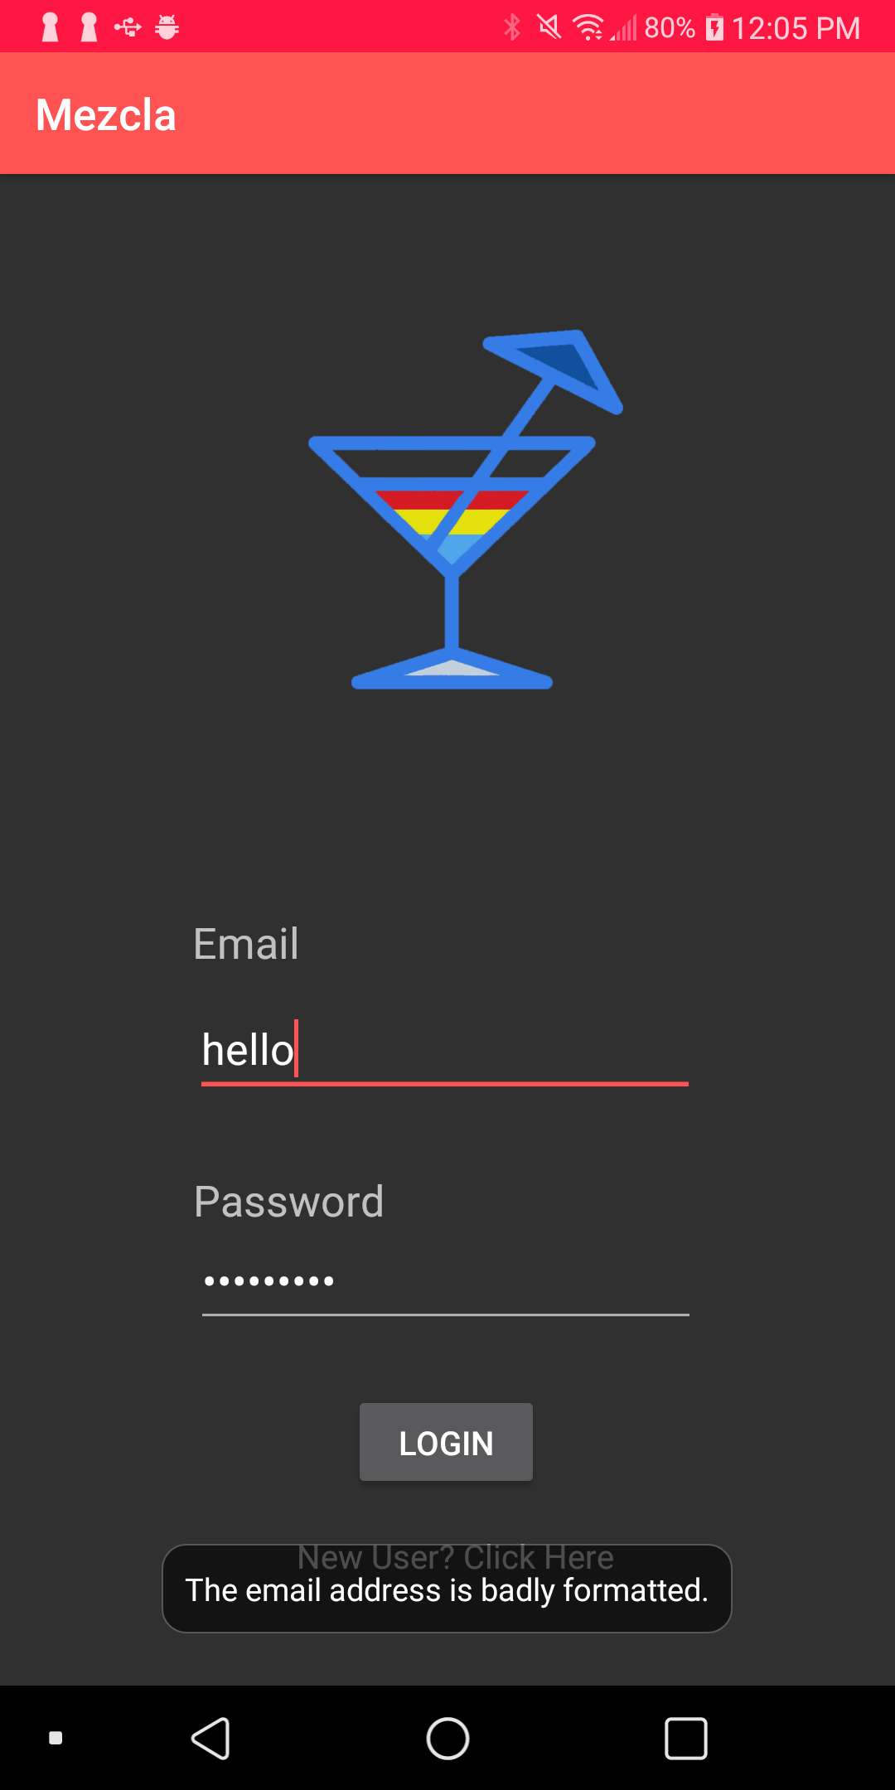

The login page will display an error message at the bottom to the user that have entered an invalid email address. For the registration and login process, we have utilized Firebase Authentication.

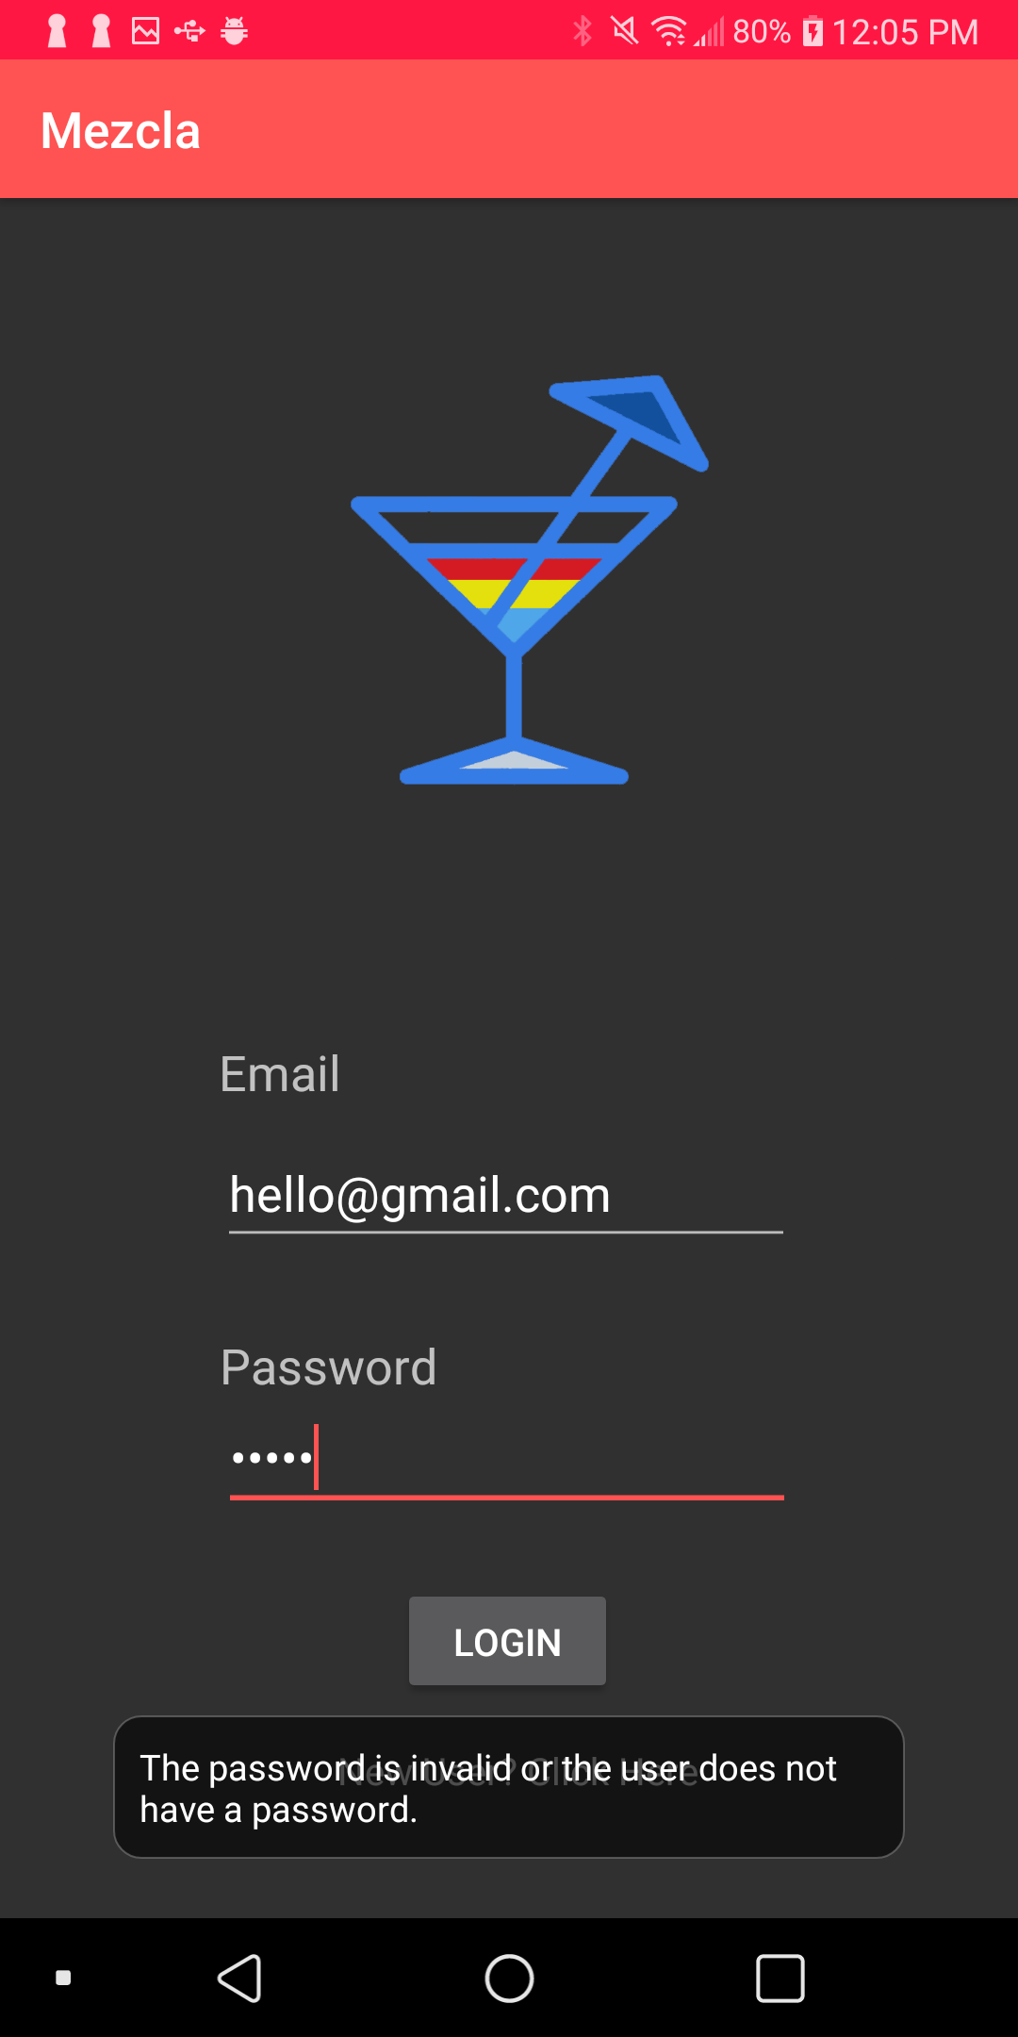

The login page will display an error message at the bottom to users that have entered an unregistered account.

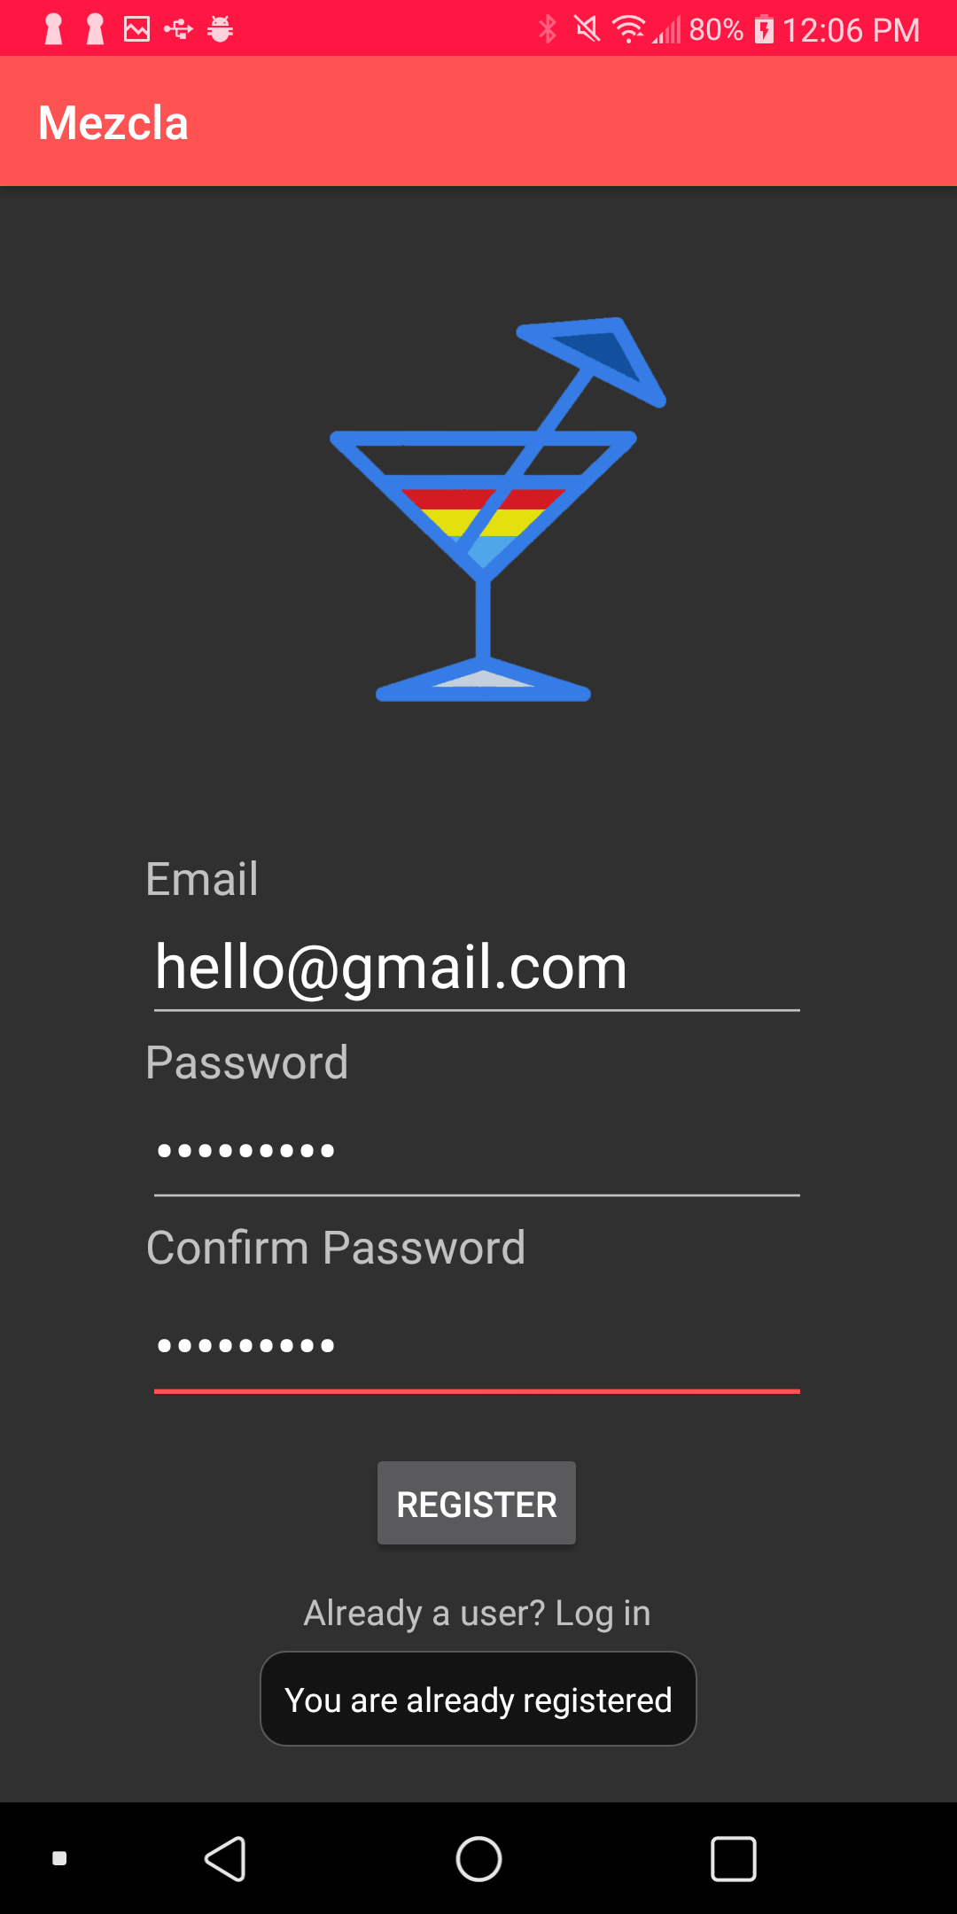

The registration page will display an error message at the bottom to users that have previously registered an account with the email address.

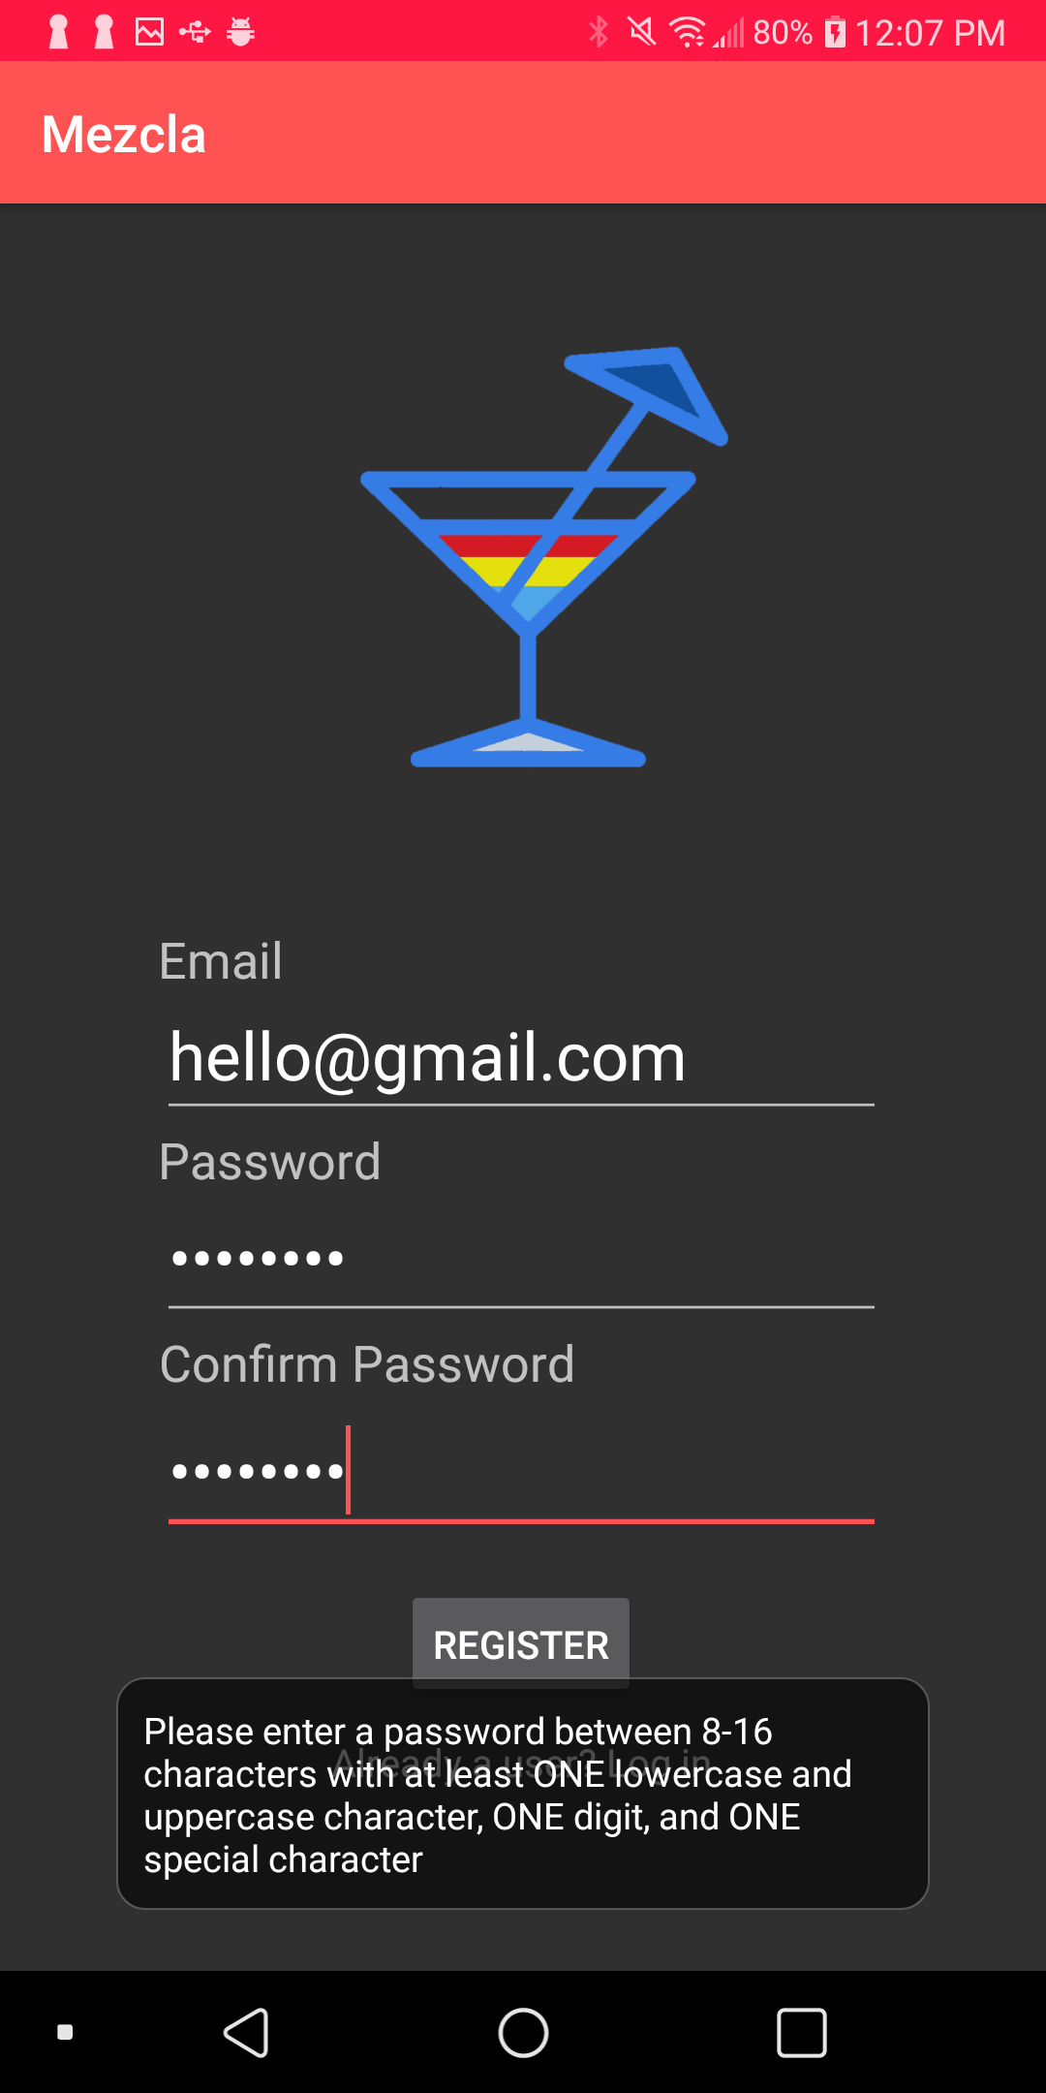

The registration page will display an error message at the bottom to users that their password does not contain lowercase, uppercase, digits, or special characters.

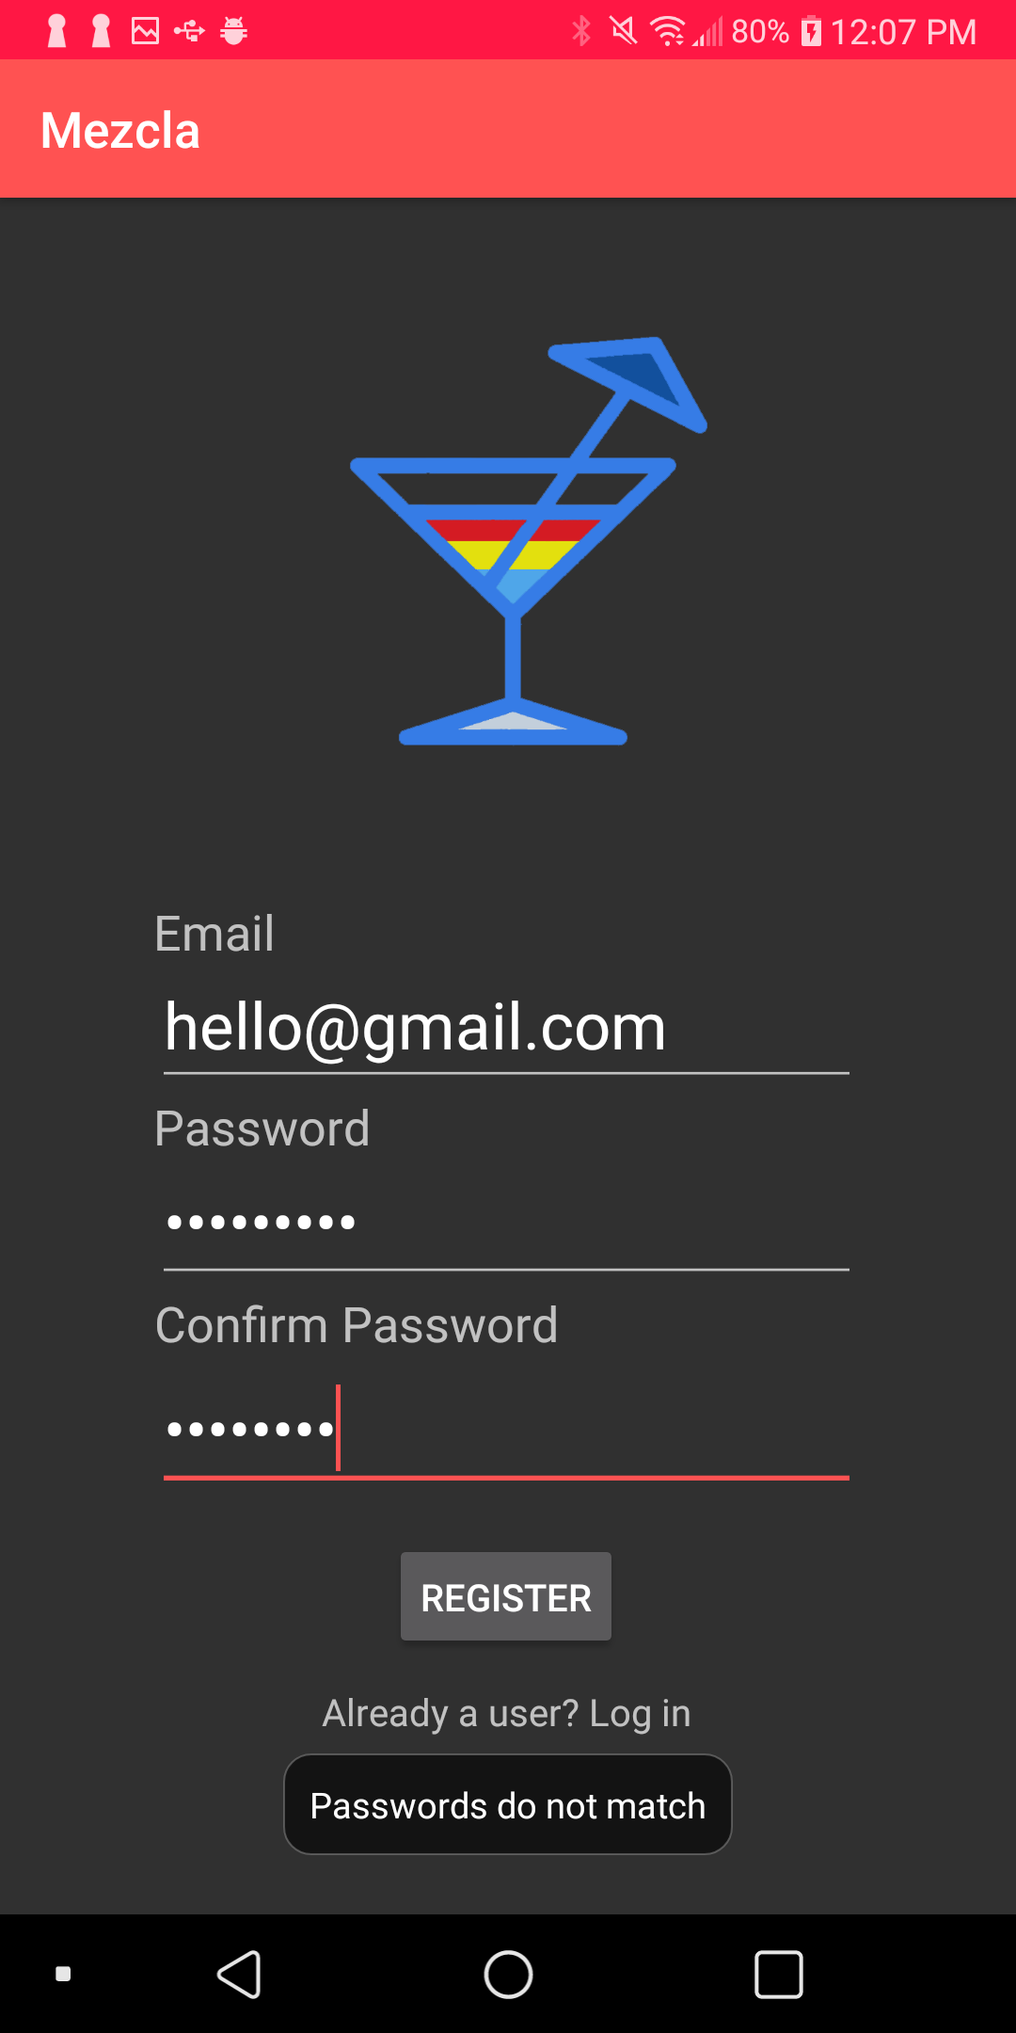

The registration page will display an error message at the bottom to users that have entered a different password.

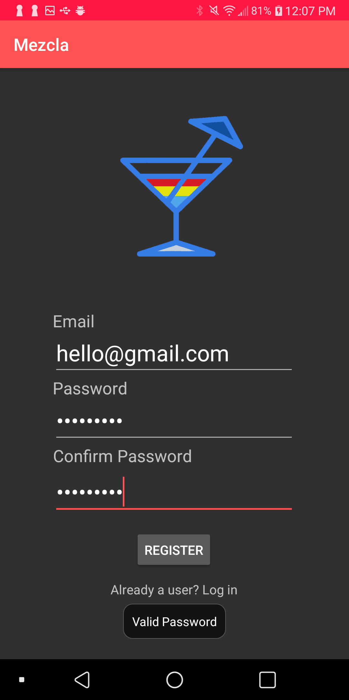

The registration page will display an error message at the bottom to tell users that their password is valid.

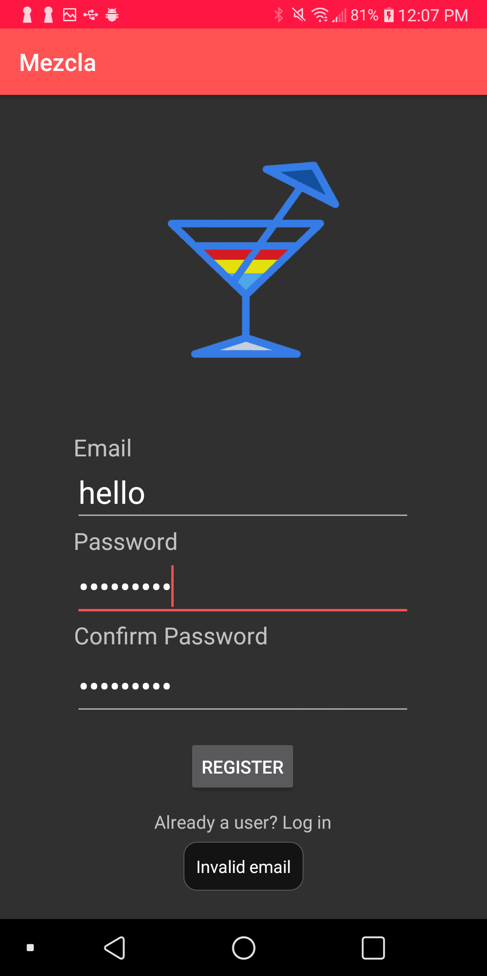

(Same as image 1 that display “Badly formatted”)

**User Guide**

New user will need to create an account in order to access the application. Mezcla will prompt the new user to enter new username, password, and a picture to upload their profile pic.

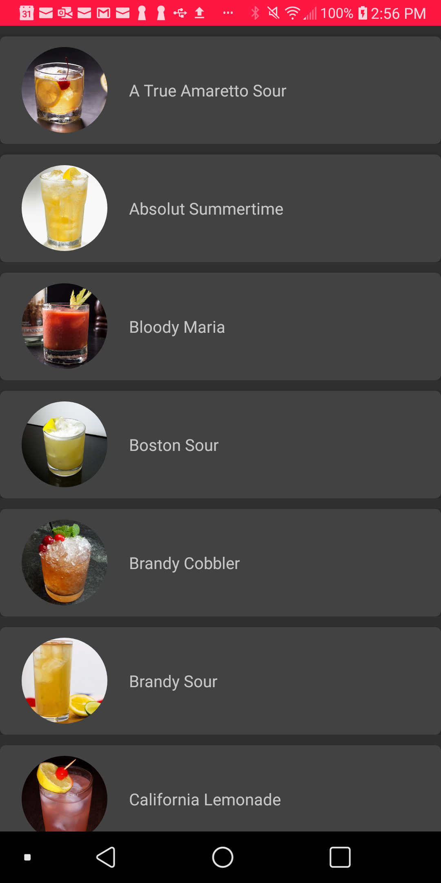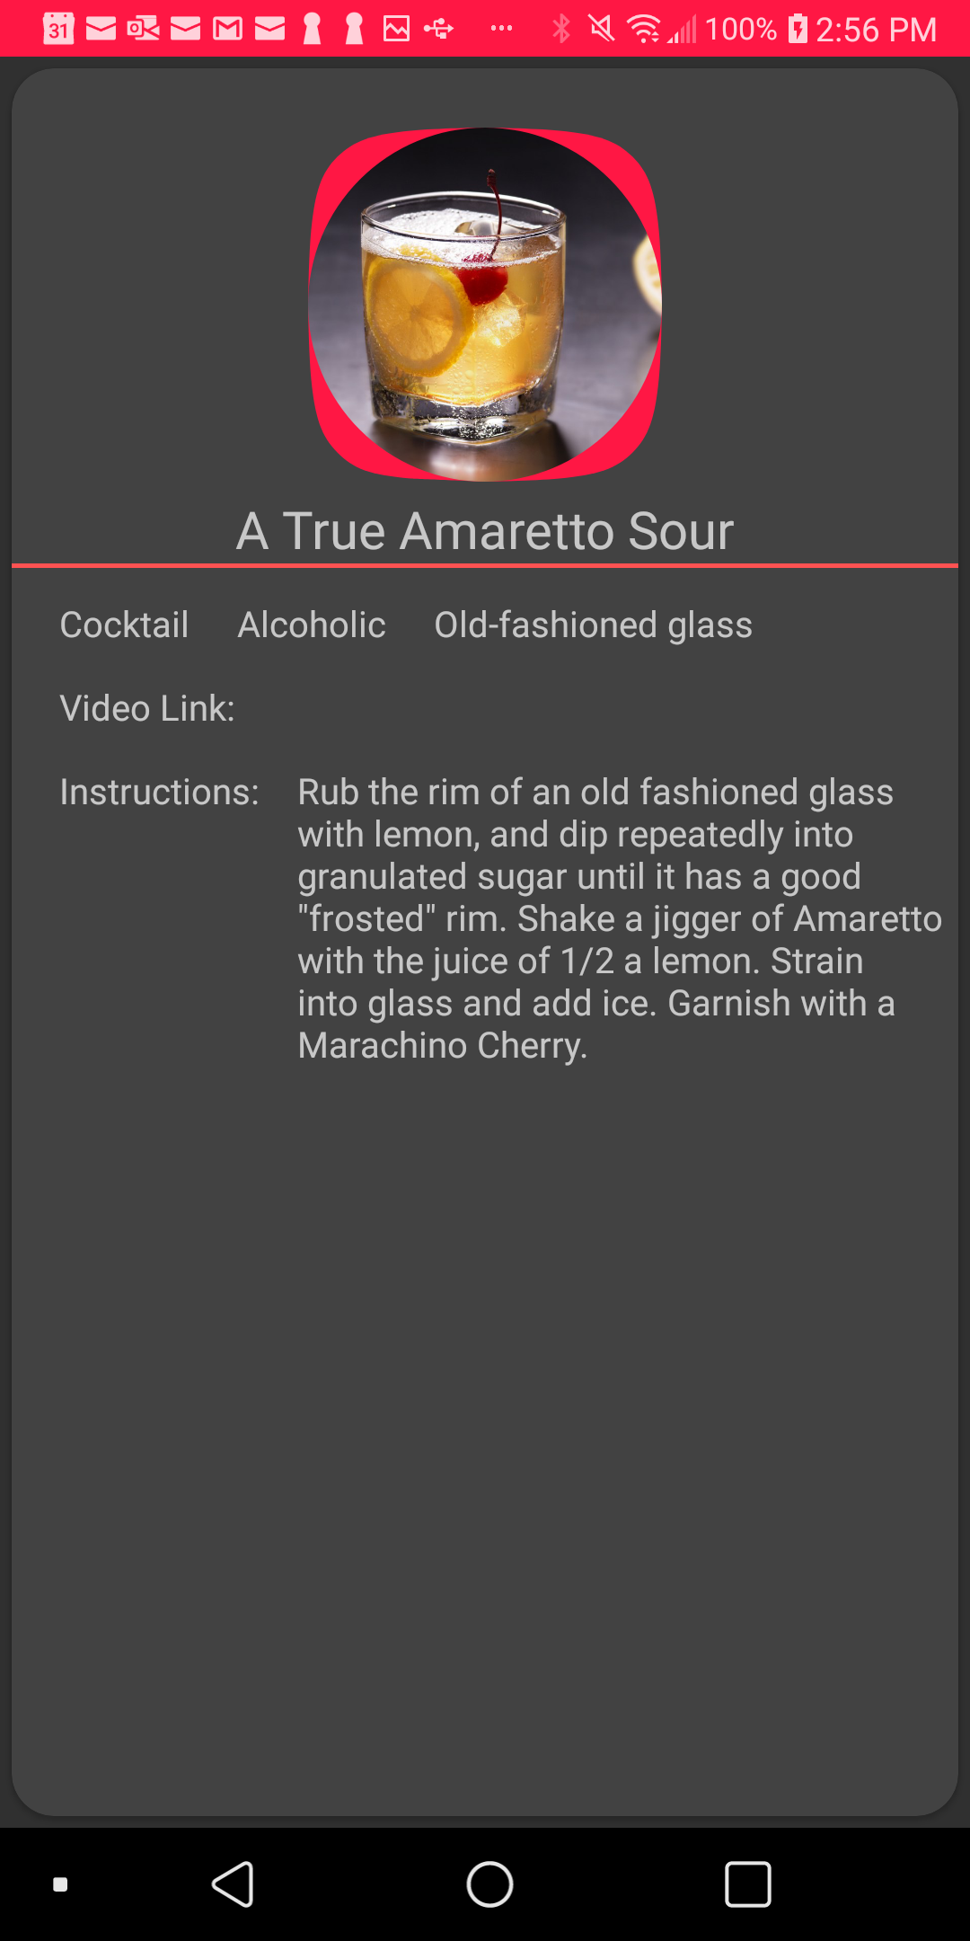

This picture occurs when user search for a particular ingredient for their drink. For example, user would like to do a search for drinks that contains lemon, Mezclar will display a list of drinks in alphabetical order and user can just select the drink to know more about its recipe.

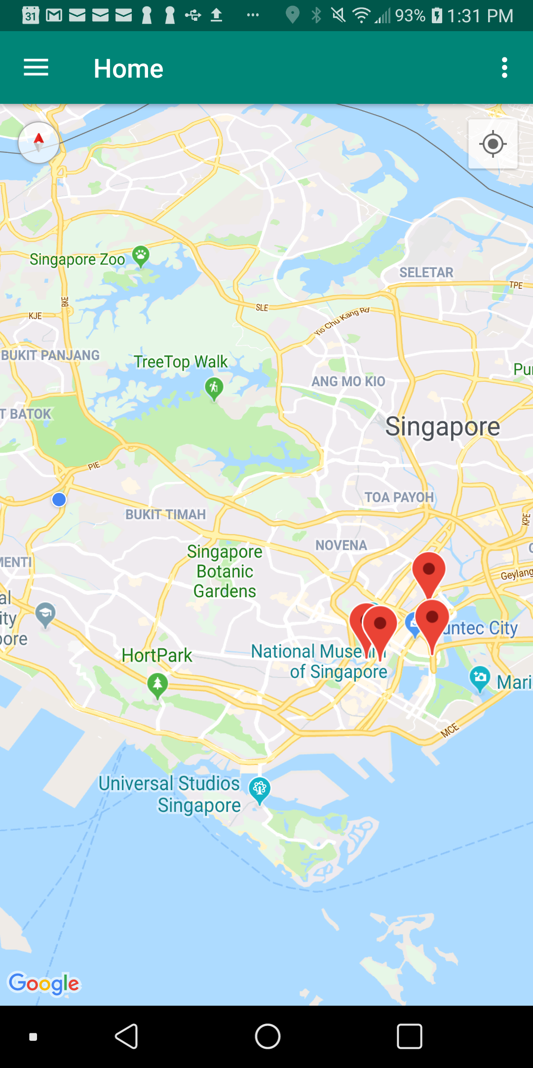

User can locate nightlife locations that are nearest to their current location in Google Map.

**Improvements made after presentation**

**Addition Search function**

Instead of searching for particular ingredients for the drink, user can just enter the name of the drink.

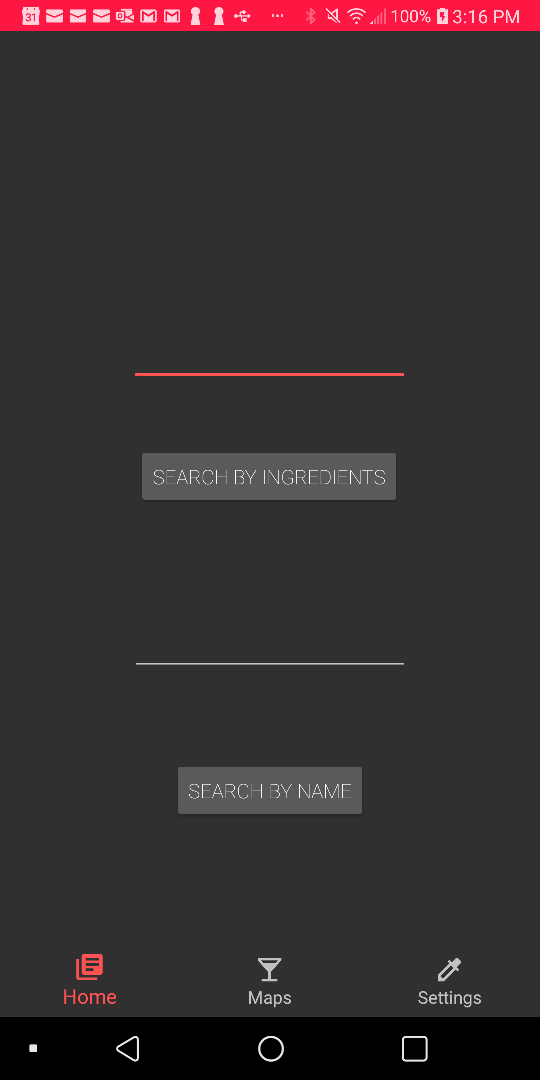

User can just type in the name of the drink and click on “SEARCH BY NAME”.

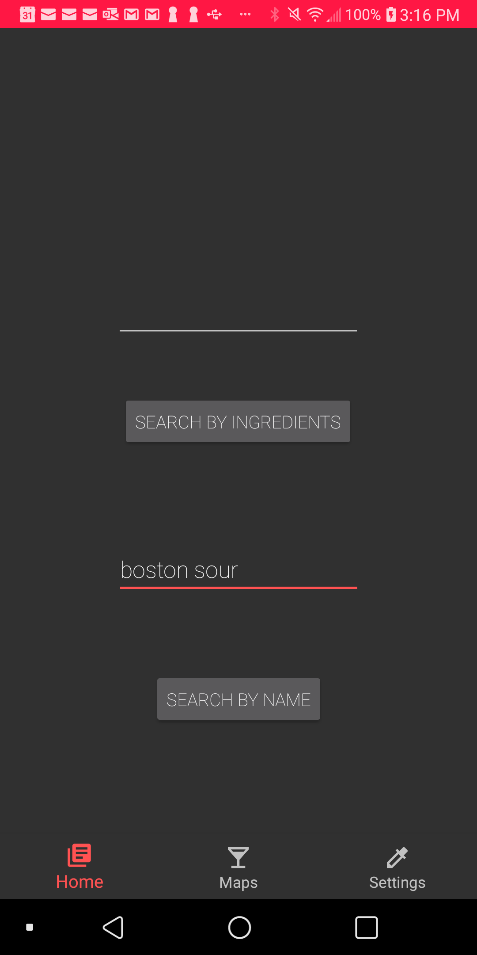

When the user type in the name of the drink and click on “SEARCH BY NAME”, Mezcla will redirect user to another page.

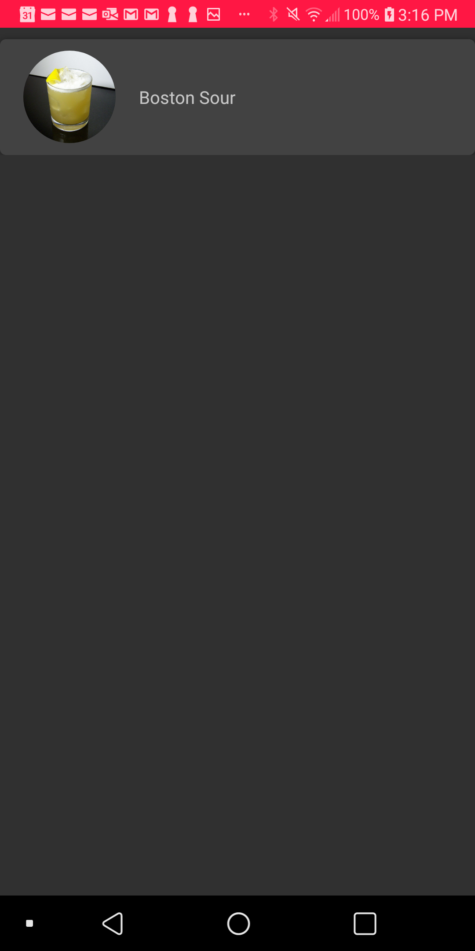

This will be the page that displays the relevant drinks according to the user search.

**Updating username and profile picture**

User can update their username and profile picture whenever they want to.

.

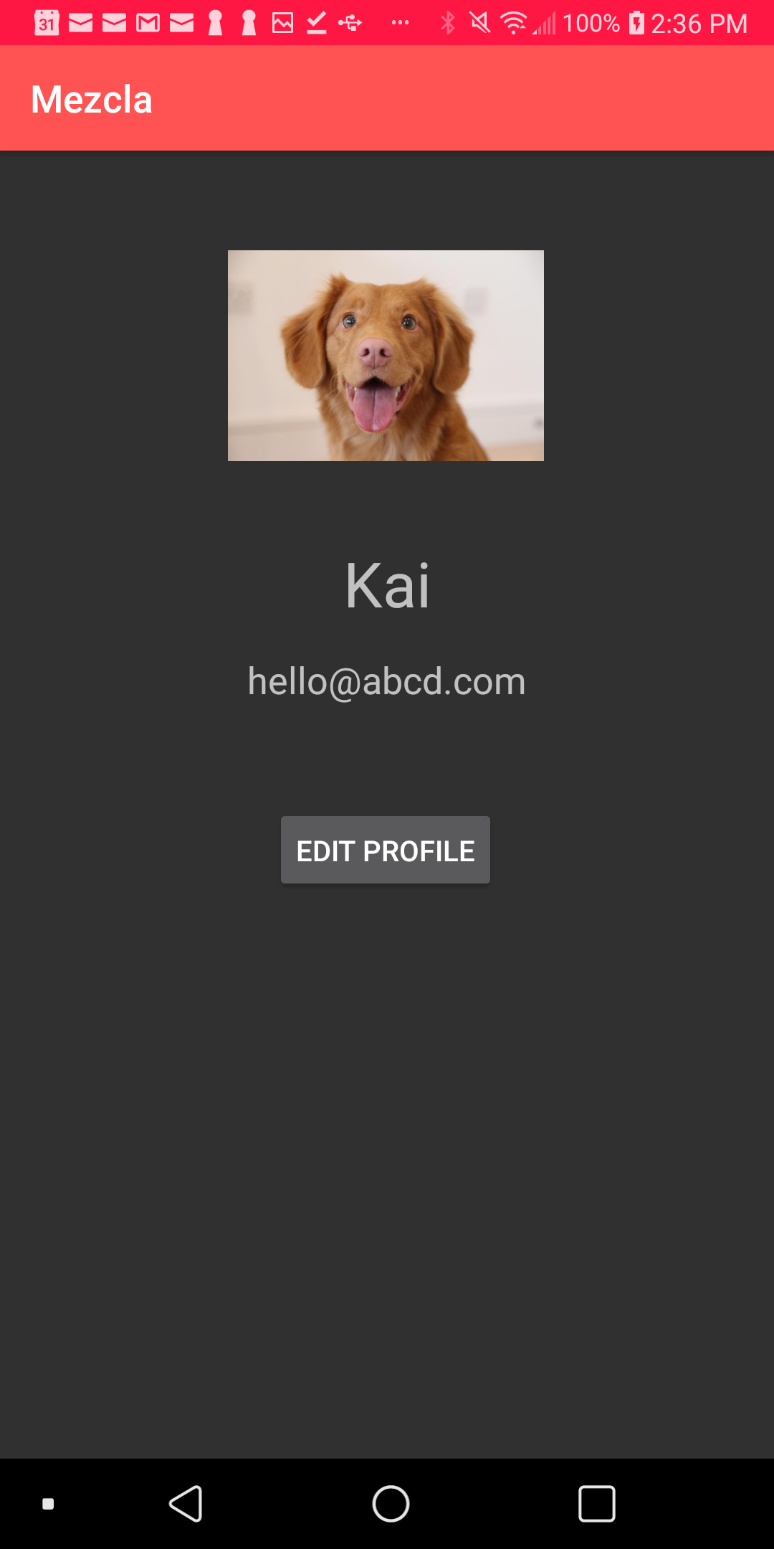

User just need to click on “EDIT PROFILE” will redirect them to another page.

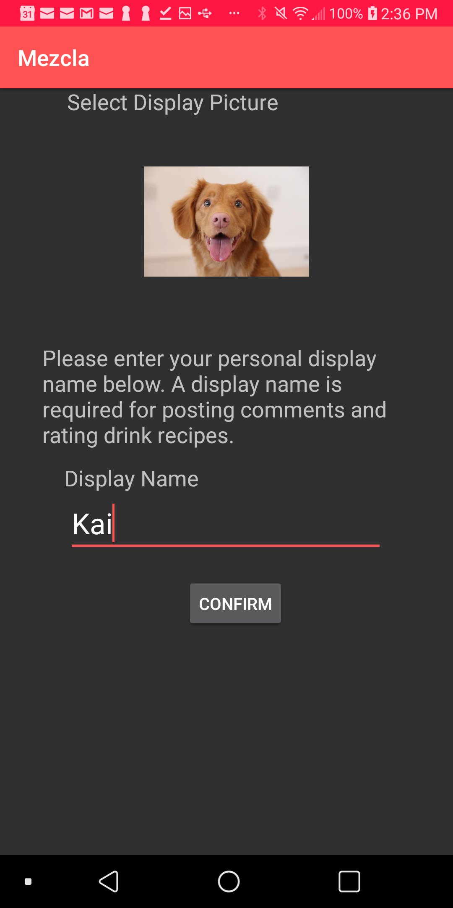

To change their profile picture, simply click on the “camera icon” and type the new display name. For this process, we have utilized “Glide” and Firebase Storage.



We have implemented the current location feature by utilizing user’s GPS. Prior to this, we have also ensured that we obtain user’s approval.

**Design and Ideation Stage**

For design and ideation stage, we have used Balsamiq Mockups 3 software for our wireframing. The following screenshots illustrate our initial ideas of the Mezcla application.

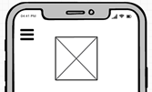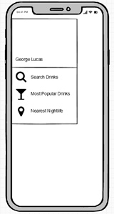

User can access to various features of the application by clicking on the top left corner of the hamburger bar which will display the features along with the username.

A list of relevant cocktail drinks will be displayed on the screen once the user clicks on the “Search” button. Assuming there are no results of the relevant drinks, user can click on the “Search Again” text to search for different ingredients.

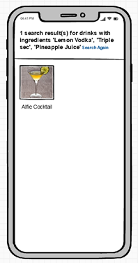

When the user clicked on a particular drink from the search list, Mezcla will display the instructions and ingredients of the drink and user are allowed to like or dislike the drink.

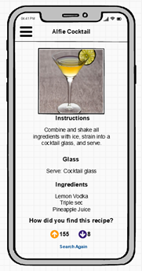

The most popular drinks are displayed from the most “likes” by the users and users can click on the “Learn More” button to find out more information of the drink. User can see the nightlife locations that are nearest to their current location in Google Map.

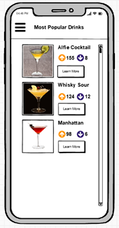

The most popular drinks are displayed from the most “likes” by the users and users can click on the “Learn More” button to find out more information of the drink.